**Manage Subscription**

**‘Pet Owner Subscriptions’ Page** – This page shows you a detailed list of pet owner subscription. Here, you will see the pet owner, pet, and product, subscription date and next delivery date. You also have the option to unsubscribe the pet owner.

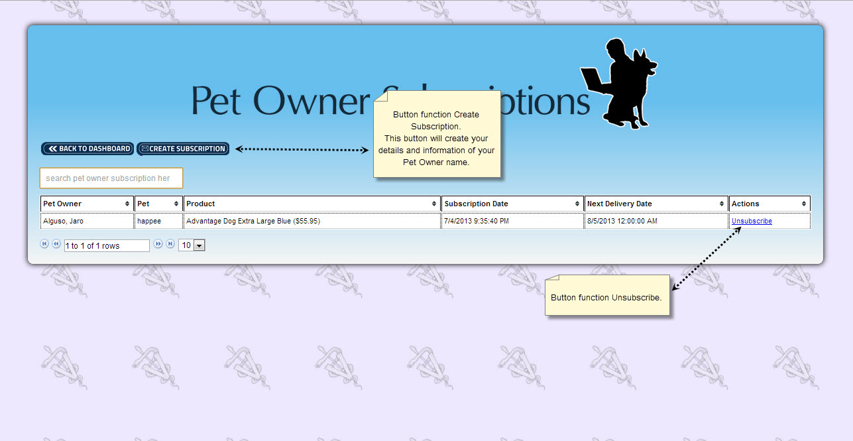

**‘Create New Subscription’ Page** – This page is where you enter type of your new user subscription and also the details of the selected subscribe user.

